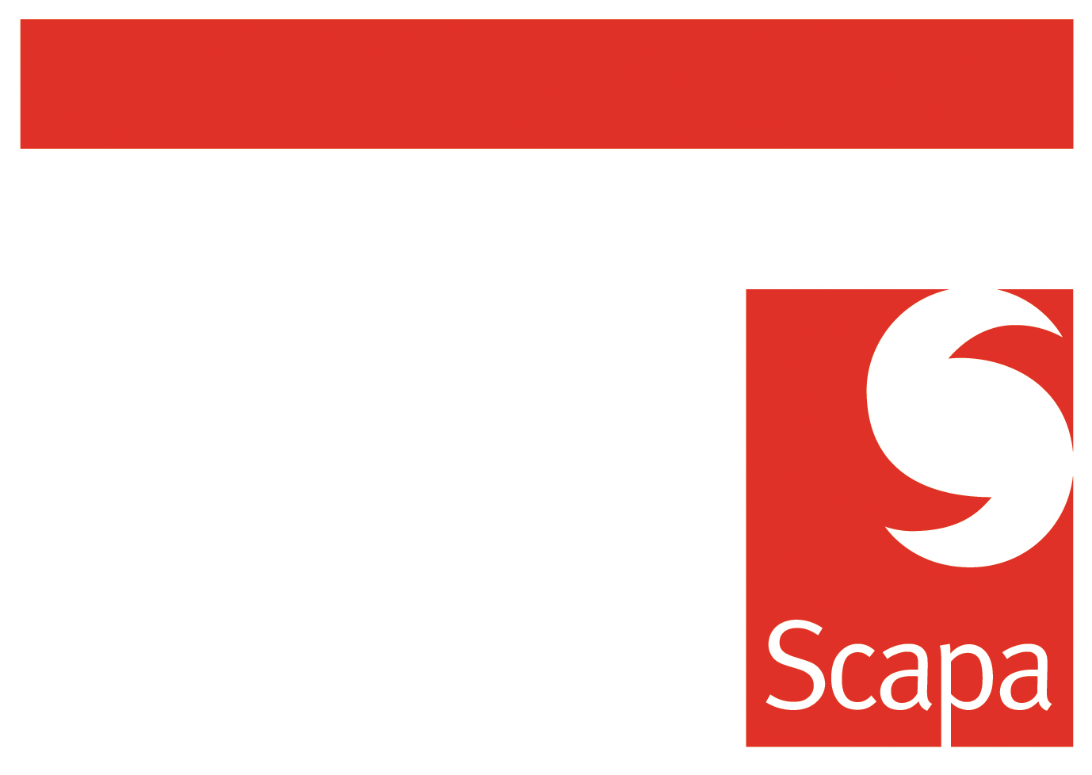
Travel and Entertainment Pre-Authorisation Form

Please complete this form with reference to the Scapa Group Business Travel and Expense.

All travel that requires an overnight stay, travel by air and customer and employee entertainment likely to exceed a cost equivalent to 300 GBP must be pre-authorised by the employee’s line manager and a Group Executive Director using this Travel and Entertainment Pre-Authorisation Form.

The exception to this rule is employees in the Commercial organisation. In this case all business trips likely to exceed a cost equivalent to 300 GBP must be pre-authorised by the employee’s line manager only. Where the cost will exceed 850 GBP then business trips must then be approved by the Group Commercial Director.

Traveller Information

Traveller Name: Department:

Contact Number: Line Manager:

Business Purpose of Travel

Itinerary
Date Leaving: Date of Return:

Leaving from: Arriving:

Leaving from: Arriving:

Leaving from: Arriving:

Anticipated Cost of travel (local currency):

Item | Required Detail | Itemised Cost | Total Cost
Hire car | Daily cost of hire & mileage
Personal car | Anticipated mileage & local mileage rate
Company car | Anticipated mileage
Flights | Itemise cost of each flight
Train | Itemise cost of each journey
Hotel accommodation | Hotel name, daily rate and number of nights

Total Cost

Approvals:

Traveller:

Line Manager:

Operating Board Director:

A copy of the pre-authorisation must be attached to the claim form.

